Chapter 7, Solution 70.

Let v = capacitor voltage.

For t < 0, the switch is open and 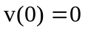.

For t > 0, the switch is closed and the circuit becomes as shown below.
v_{S}
+
−
v_{o}

+
−
+ 
v
R
C
1
2

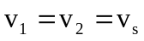 (1)
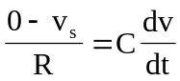 (2)
where 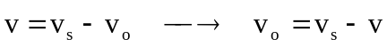 (3)

From (1),
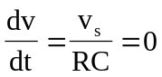
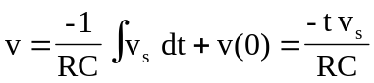

Since v is constant,
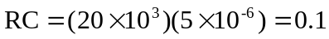
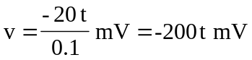

From (3),
